HNRS 125- Seminar 1: The Arts in NYC Queens College, CUNY
Fall 2025 Final Presentation

Throughout the semester, you have explored how the arts- film, visual arts, dance, poetry, music, and opera- can inspire, challenge, and provoke meaningful reflection. Today, we experience the arts not only through in-person visits to museums, theaters, and cultural organizations, but also through digital platforms that bring creative expression directly into our homes. Whether watching films, exploring virtual museum tours, or streaming performances, we now have multiple ways to connect with New York City’s vibrant artistic landscape.

In recent years, there has also been a rise in creatively reimagining famous artworks using everyday materials. Online communities, such as the Dutch Instagram account Tussen Kunst & Quarantaine (Between Art and Quarantine) and initiatives by institutions like the J. Paul Getty Museum have inspired people to recreate artworks in clever, playful, and imaginative ways using items found at home.

The idea behind this practice connects to the tradition of the tableau vivant, French for “living picture.” In the 19th century, long before television or digital media, audiences would attend performances in which actors posed to recreate scenes from literature, art, history, or daily life. Friends and families also created these tableaux at gatherings as a form of entertainment and artistic appreciation. Today, this concept has been revived through photography and social media.
Here are contemporary examples of recreated tableaux vivants using everyday household objects:
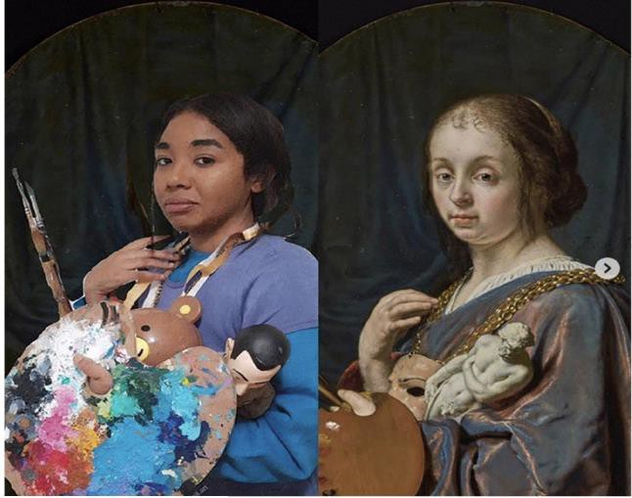

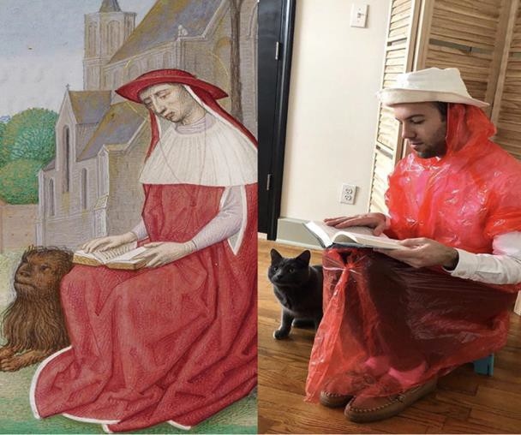

Left: Frans van Mieris the Elder, Pictura
(An Allegory of Painting),
1661, Oil on copper.
Recreated by @creamii.art (courtesy the J. Paul Getty Museum)

Right: Workshop of Master of the First Prayer Book of Maximillian, St. Jerome Reading (detail), 1475- 1515,
Tempera colors, gold, and ink on parchment.
Recreated by @newberrylibrary (courtesy the J. Paul Getty Museum)

What is the final project?
For your final presentation, you will be recreating a work of art of your choosing! This project will require you to stretch your creativity, imagination and experience with art. Follow the instructions to help you on your way:
- Research! Look through the Instagram account of @tussenkunstenquarantaine to see what people have been recreating and gain some inspiration.
- Browse through New York City art museum websites and look for a work of art (painting or sculpture only) that captivates you and motivates you to recreate it.
*Note: Your selected artwork should not contain nudity, profanity, or inappropriate gestures.
- Once you find a work of art, carefully observe it and think about what materials/objects from your home you can incorporate to recreate it.
- Be CREATIVE! Think like both an artist and a storyteller: how will you bring this artwork to life? (you will need to use at least 4 different household items) Will you be a part of it? Or will this be a recreation using only objects and different materials? Again, the purpose of this is for you to be as creative and imaginative as you can be and have fun doing it!!
- Photograph your final tableau and upload it to the slide presentation that shows the artwork you chose and the recreation side by side. You will use this to present to the class on December 9 or 11, 2025. Each student will have 5 minutes to present.
You must upload your slide by December 7 at 11:59PM.
- Ensure you have the proper credit lines for the work of art you pick (artists name, title, date, Museum, etc). This information is easily found on a museum's website when you click on the specific object. You can add this to the slide presentation under the "speaker notes" section along with your name.
- Optional: If you are active on Instagram account, share it and tag the museum where you recreated the work of art from. Use the hashtag # HNRS125

The purpose of this final project is for you to take everything we have been discussing in class during the semester and think critically about how you approach and engage with works of art. By recreating an artwork through your own lens, you will practice thinking like an artist, filmmaker, composer, or poet—considering composition, materials, symbolism, and creative problem-solving.
Most importantly, approach this project with curiosity, imagination, and joy. Have fun with the process!

